Internal Assessment Resource
Agricultural and Horticultural Science Level 1
EXPIRED
This resource supports assessment against:
Achievement Standard 90922 version 2
Design a landscape plan that reflects user requirements
Resource title: Redesigning Enato Park
3 credits
This resource:
- Clarifies the requirements of the standard
- Supports good assessment practice
- Should be subjected to the school’s usual assessment quality assurance process
- Should be modified to make the context relevant to students in their school environment and ensure that submitted evidence is authentic

Date version published by Ministry of Education | February 2015 Version 3  To support internal assessment from 2015
Quality assurance status | These materials have been quality assured by NZQA.  NZQA Approved number A-A-02-2015-90922-02-4362
Authenticity of evidence | Teachers must manage authenticity for any assessment from a public source, because students may have access to the assessment schedule or student exemplar material.  Using this assessment resource without modification may mean that students’ work is not authentic. The teacher may need to change figures, measurements or data sources or set a different context or topic to be investigated or a different text to read or perform.

Internal Assessment Resource
Achievement Standard Agricultural and Horticultural Science 90922: Design a landscape plan that reflects user requirements
Resource Reference: Agricultural and Horticultural Science 1.8A v3
Resource Title: Redesigning Enato Park
Credits: 3
Teacher guidelines
The following guidelines are designed to ensure that teachers can carry out valid and consistent assessment using this internal assessment resource.
Teachers need to be very familiar with the outcome being assessed by Achievement Standard Agricultural and Horticultural Science 90922. The achievement criteria and the explanatory notes contain information, definitions, and requirements that are crucial when interpreting the standard and assessing students against it.
Context/setting
In this assessment activity, students are to redesign a park site to meet the requirements of the Summerton Council and the needs of the members of the community who will use it. The council would like to use the land for a new swimming pool and kindergarten, as well as continuing to cater for visitors to the park.
The student’s design plan should consider user requirements, for example, access, privacy, shelter, shade, aesthetics, recreation, entertainment, and utility. The student also needs to identify the environmental factors impacting on the site, and justify how their use of hard and soft landscape features will comprehensively meet the needs of the users in a functional manner.
Conditions
This is an individual assessment task. Students will be assessed on their ability to design a landscape plan that comprehensively meets user requirements. Provide detail for students about the time allowed to complete the task.
Resource requirements
Students will require copies of the three resource sheets. Resource 3 (the design plan sheet) should be provided on A2-size paper. You might like to produce your own version of this, to suit the needs of your students.
Copies of landscape design magazines would be useful to provide ideas and inspiration for students.
Additional information
None.

Internal Assessment Resource
Achievement Standard Agricultural and Horticultural Science 90922: Design a landscape plan that reflects user requirements
Resource reference: Agricultural and Horticultural Science 1.8A v3
Resource title: Redesigning Enato Park
Credits: 3
Achievement | Achievement with Merit | Achievement with Excellence
Design a landscape plan that reflects user requirements. | Design a landscape plan that meets user requirements. | Design a landscape plan that comprehensively meets user requirements.
Student instructions
Introduction
The Summerton Council is running a competition to redesign a park called Enato Park. The park is currently used for club football and cricket in the weekend, but the weekend sports are moving to a new location in another part of town. The council would like to use the land for a new swimming pool and kindergarten, as well as continuing to cater for visitors to the park.
This assessment activity requires you to redesign the park site, so that it is enhanced to meet the requirements of the council and the needs of the members of the community who will use it.
User requirements are those determined by the user of the site, for example, access, privacy, shelter, shade, aesthetics, recreation, entertainment, production, utility, budget constraints.
You will need to draw a plan for the site, and justify how the redesigned site will comprehensively meet the needs of the council and the proposed users in a functional manner. This will involve comparing and/or contrasting location and attributes of hard and soft landscape features.
This is an individual assessment task. You will be assessed on your ability to design a landscape plan that comprehensively meets user requirements.
Teacher note: Provide detail for students about the time allowed to complete the task.
Task
Design plan
Redesign the Enato Park site (see Resource 1), considering how you will use hard and soft landscaping features to meet the council’s requirements. Their requirements are:
- a swimming pool
- a kindergarten
- access for vehicles and walkers into the park from the intersection at the south end
- a car park
- shelter (from the wind)
- shade (from the sun).
Use the symbols provided (Resource 2), or other labelled symbols, to identify the position of new features that you include. Draw your new design plan to scale on the large, A2-sized plan sheet provided (Resource 3).
You should also consider:
- how the park might be used by the community
- the aesthetic appeal (making it look nice)
- any privacy issues
- access within the park
- scale
- environmental factors.
Notes to support your design plan
You will need to write notes that explain and justify your design decisions. This will involve comparing and/or contrasting location and attributes of hard and soft landscape features. Explain and justify in terms of functionality:
- how your design meets council and user requirements
- the hard and soft features you have chosen to use, and how the use of these features meets user requirements
- how the new features link to the existing features of the park, and how new features link to each other
- the impact that environmental factors have had in determining the location of the features.
Functionality refers to the facilitation of user activities/requirements. This involves consideration of scale and environmental factors.

Resources
Resource 1: Enato Park, Summerton
Summerton receives moderate rainfall (mainly in the winter time) and the prevailing wind is from the north. The soil is free draining, except for the clay based cricket wickets.
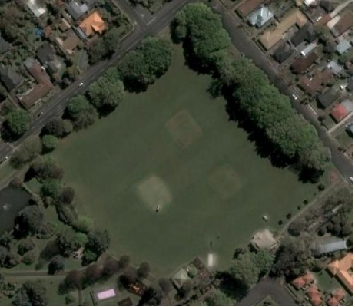

[Source: Google Earth]
Resource 2: Design symbols
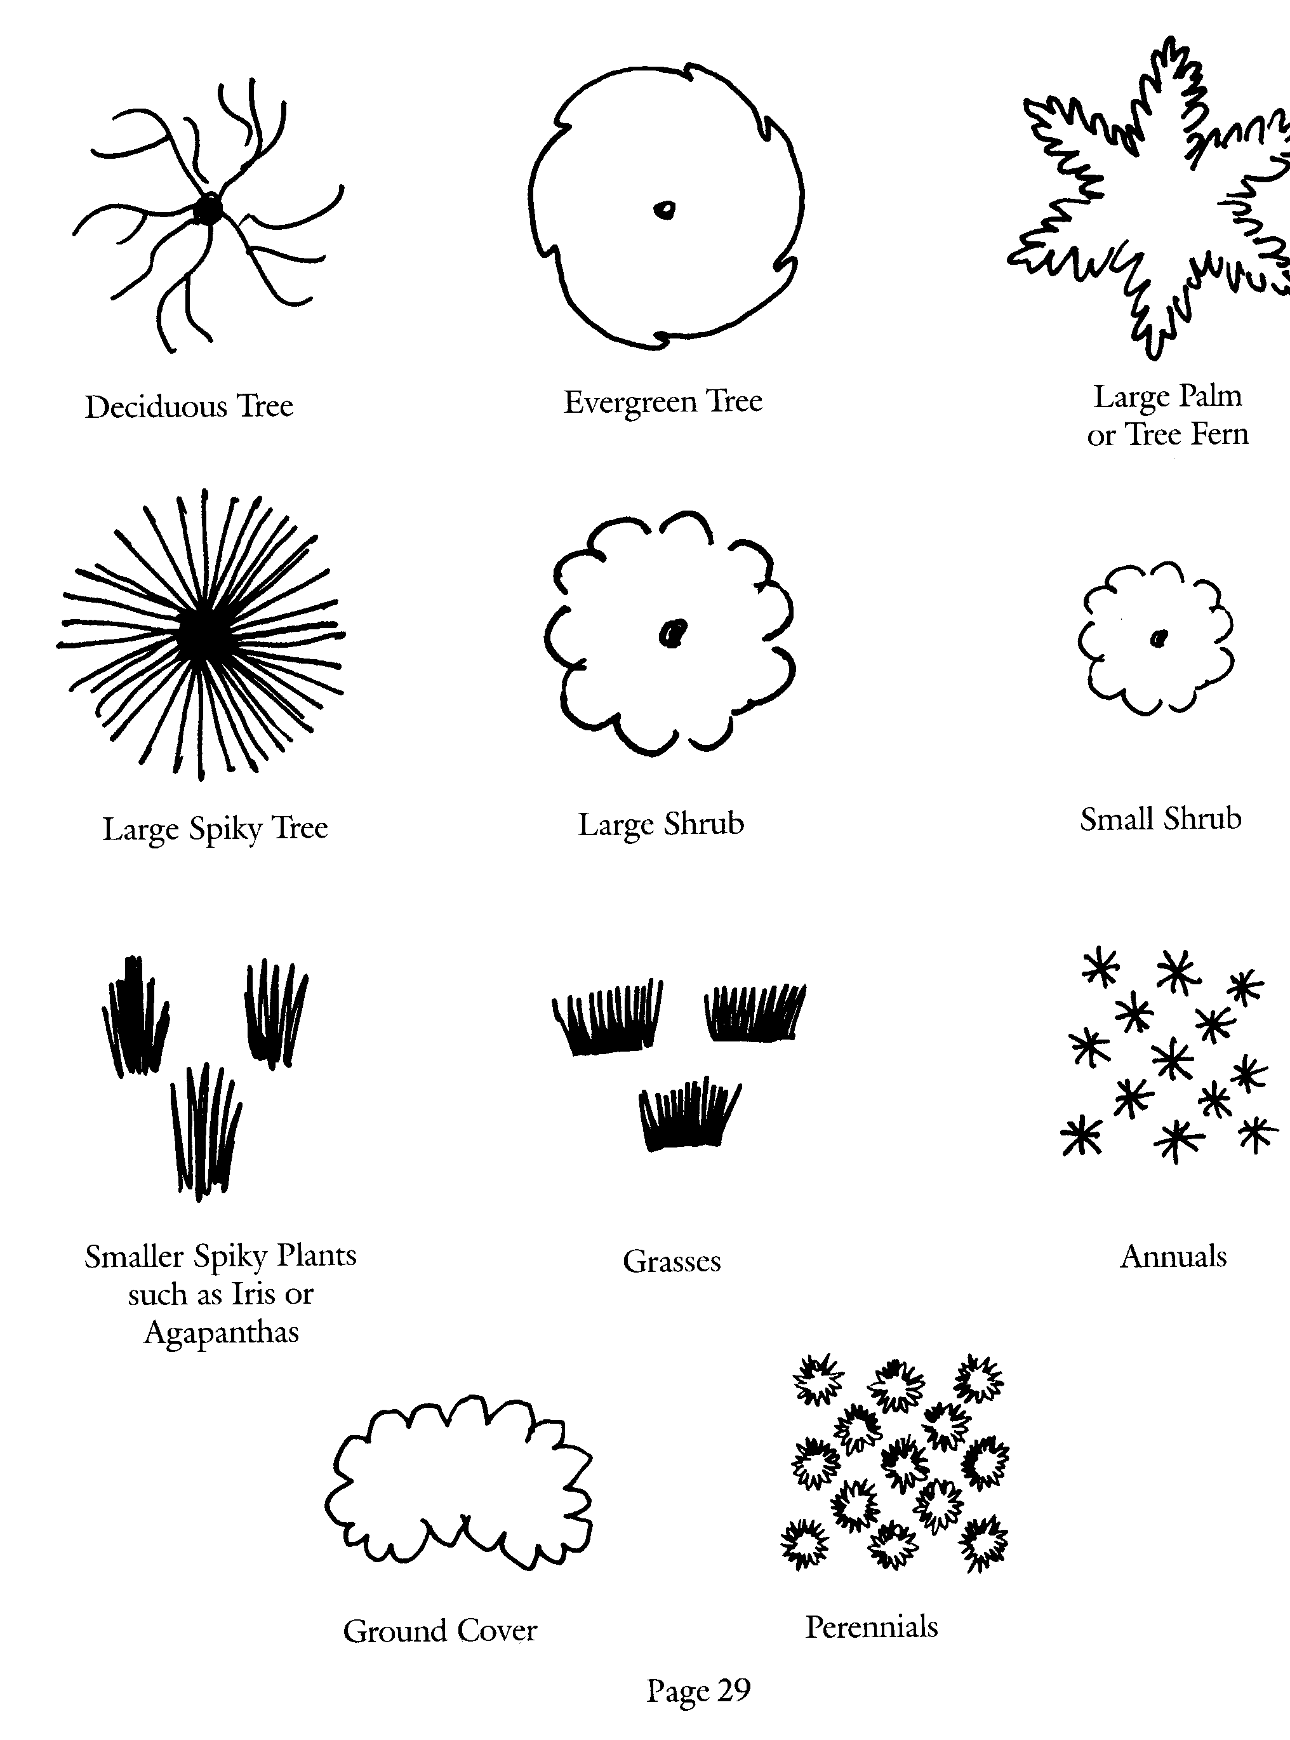 | 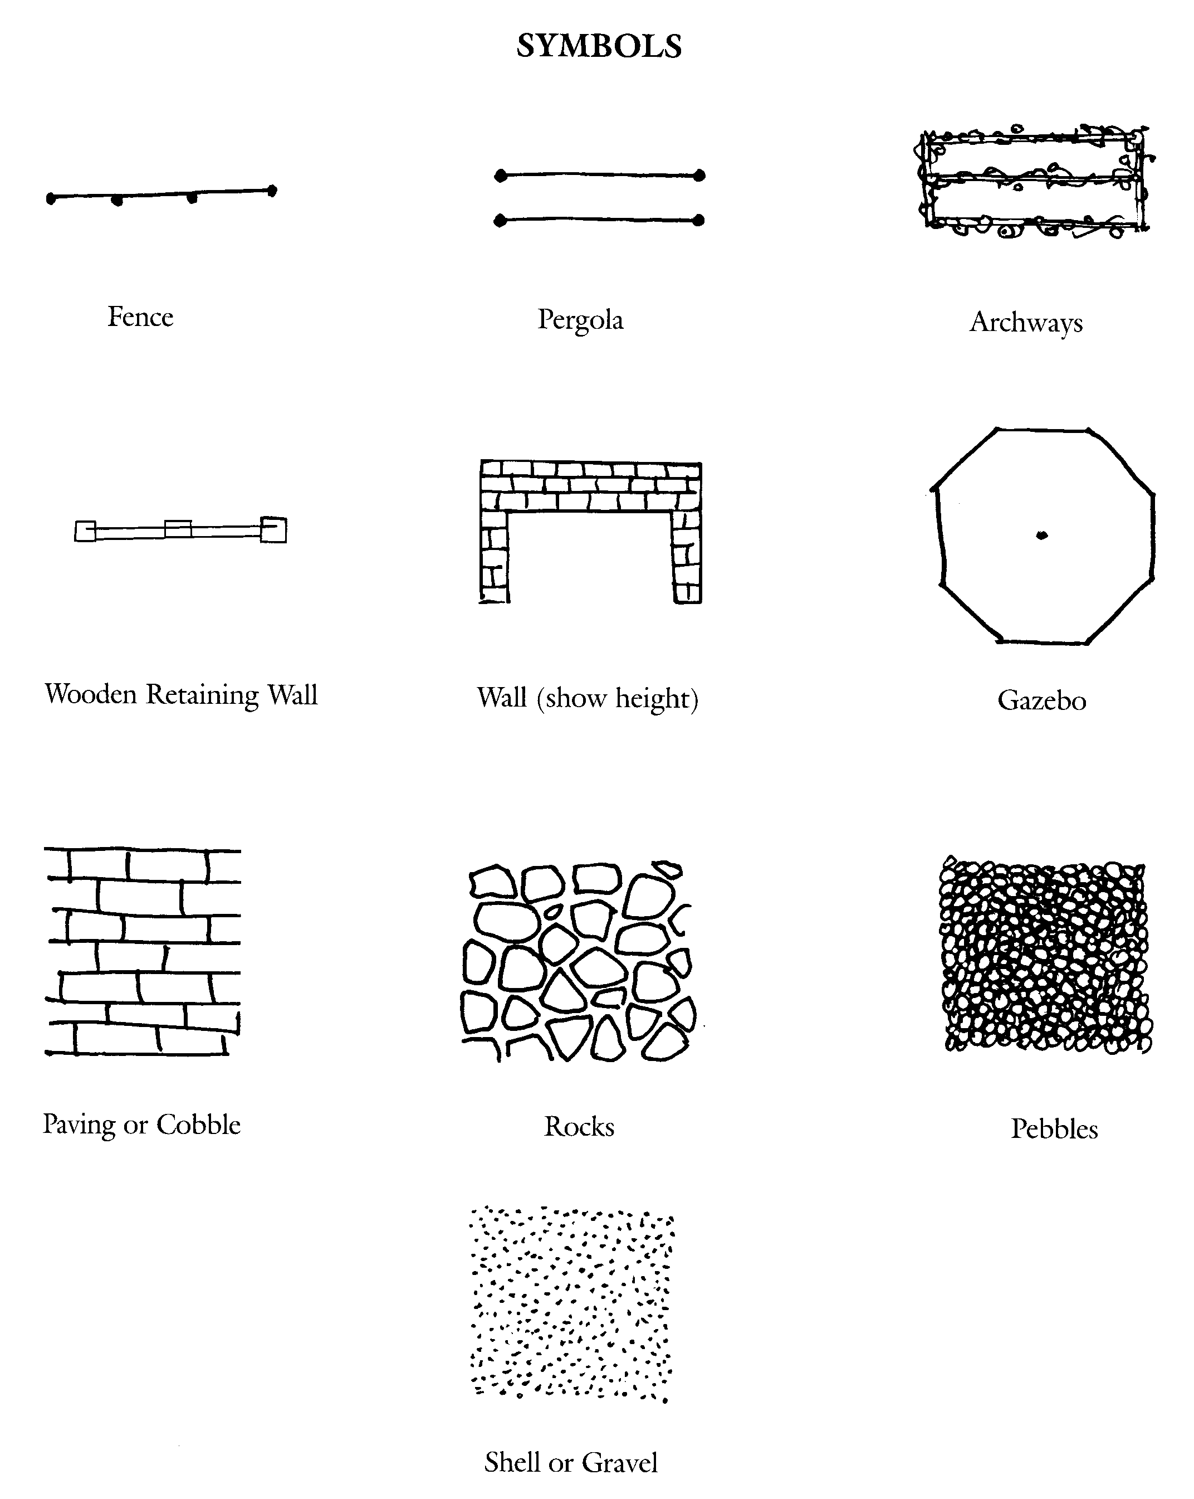
[Source: The Ellerslie Flower Show – An introduction to Garden Design]


Resource 3: Design plan sheet


N
The entrance to the park must be from this intersection
Scale: 1cm = 5m
Note to teacher:
This redesign plan sheet must be printed on A2 sized paper
N
Assessment Schedule: Agricultural and Horticultural Science 90922 Redesigning Enato Park
Evidence/Judgements for Achievement | Evidence/Judgements for Achievement with Merit | Evidence/Judgements for Achievement with Excellence
The designed landscape plan has appropriate features drawn in locations that would enhance the park to reflect the requirements of the Summerton Council and the users.  This would include a detailed drawing using labelled symbols that identify the positions of the new features including:  - significant plants/groups of plants (specific scientific names are not required; however it would be expected that students will describe the type of plant or growth habit)  - hard features (for example, paths, seats, walls, rubbish bins).  In meeting the needs of the local council and the users, at least three significant needs are addressed. They must include a swimming pool and a kindergarten somewhere in the park.  The written notes give superficial reasons for the location of the majority of the features, but may not demonstrate functionality.  For example, a student could give the following reason for the location of the kindergarten:  The kindergarten is close to the car park for easy access. | The designed landscape plan has appropriate features drawn in locations that would enhance the park to meet the requirements of the Summerton Council and the users in a functional manner.  Students refer to the linkages between the new features and also between the new and existing features and the impact that environmental factors have had in determining their location.  This would include a detailed scale drawing using labelled symbols that identify the positions of the new features:  - significant plants/groups of plants (specific scientific names are not required; however it would be expected that students will describe the type of plant or growth habit)  - hard features (for example, paths, seats, walls, rubbish bins).  In meeting the needs of the local council and the users, at least three significant needs are addressed. They must include a swimming pool and a kindergarten somewhere in the park in a functional location.  The written notes give reasons for the location of the majority of the features and demonstrate how the features are functional; and the impact that environmental factors have on the locations.  For example, a student could give the following reasons for the location of the kindergarten.  The kindergarten is close to the car park so that families will not have to walk too far. It is also on the opposite side to the swimming pool to ensure the children remain safe.  Trees around the perimeter of the park are maintained to ensure that shelter is provided from the prevailing northerly wind. | The designed landscape plan has appropriate features drawn in locations that would enhance the park to comprehensively meet the requirements of the Summerton Council and the users in a functional manner.  Students refer to the linkages between the new features and also between the new and existing features and the impact that environmental factors have had in determining their location.  This would include a detailed, scale drawing using labelled symbols that identify the positions of the new features:  - significant plants/groups of plants (specific scientific names are not required; however it would be expected that students will describe the type of plant or growth habit)  - hard features (for example, paths, seats, walls, rubbish bins).  In meeting the needs of the local council and the users, at least three significant needs are addressed. They must include a swimming pool and a kindergarten somewhere in the park in a functional location; access, car park, shade and shelter.  The written notes give reasons for the location of the majority of the features and comprehensively demonstrate how they meet the requirements of the council in a functional manner: This must include the consideration of scale and environmental factors.  For example, a student could give the following reasons for the location of the kindergarten.  The kindergarten is close to the car park so that families will not have to walk too far. It is also on the opposite side to the swimming pool to ensure the children remain safe. Being on the southern end of the park there will be all day sun; however the shade sail will provide the children sufficient shade. The hedge will block the northerly wind and isolate the kindergarten from the park in a way that will not encourage graffiti as a solid wall would.
Final grades will be decided using professional judgement based on a holistic examination of the evidence provided against the criteria in the Achievement Standard.

